Monday, June 12, 2017 – Physics and Math Majors
8:00am-8:00pm
8:00am-9:00am | Using ACOS to Develop Lessons  Dennis Sunal  Krystal Flantroy  Jeremy Zelkowski  Noyce Interns, Teacher Mentors | 3408 SEC
9:00am-11:00am | Develop HS Exploration Day Activities & Research Project  Noyce Interns, Teacher Mentors | 3408 SEC
11:00am-12:00pm | Lunch | On your own
12:00pm-12:30pm  12:30pm-3:00pm | Travel to TCTA  Assist in TCTA Classes  – Summer of Coding  Noyce Interns, Teacher Mentors | TCTA
3:00pm-4:00pm | Travel To Moundville | In Van from TCTA
4:00pm-8:00pm | Moundville Field Trip and Planning Exploration Day Meeting  All Noyce Personnel, Noyce Interns, Teacher Mentors | Conference Center
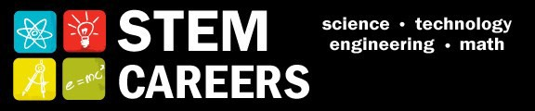
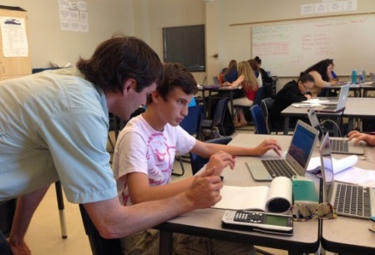

Tuesday, June 13, 2017 – Physics and Math Majors
8:00am-5:30pm
8:00am-11:30am | Develop HS Exploration Day Activities & Research Project  Noyce Interns, Teacher Mentors | 3408 SEC
11:00am-12:00pm | Lunch | On your own
12:00pm-12:30pm  12:30pm-5:30pm | Travel to TCTA  Assist TCTA Classes  -Summer of Coding | Hub Parking Lot  TCTA

Wednesday, June 14, 2017 – Physics and Math Majors
8:00am-5:30pm
8:00am-9:00am | Using ACOS to Develop Lessons  Noyce Interns, Noyce Program Personnel, Teacher Mentors | 3408 SEC
9:00am-11:00am | Lesson Literature Review  Noyce Interns, Noyce Program Personnel, Teacher Mentors | Rodgers Library
11:00pm-12:00pm | Lunch | On Your Own
12:00pm-12:30pm  12:30pm-5:30pm | Travel to TCTA  Assist in TCTA Course-  Summer of Coding  Noyce Interns, Teacher Mentors | TCTA
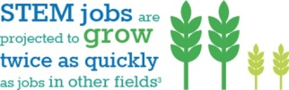

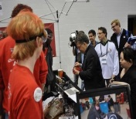

Thursday, June 15, 2017 – Physics and Math Majors
8:00am-6:30pm
8:00am-11:30am | Develop HS Exploration Day Activities & Research Project  Noyce Interns, Noyce Program Personnel, Teacher Mentors | 3408 SEC
11:30-12:30pm | Lunch | On Your Own
12:30pm-1:00pm | Travel to TCTA | Hub Parking Lot
1:00pm-5pm | Assist in TCTA Classes-  Summer of Coding  Noyce Interns, Noyce Program Personnel, Teacher Mentors | TCTA
5:00pm-5:30pm  5:30pm-6:30pm | Travel to SCP  Exploration Planning Meeting  Noyce Interns, Noyce Program Personnel, Teacher Mentors | In Van - Travel
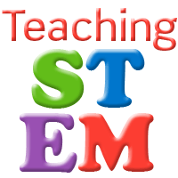
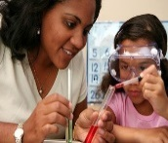

Friday, June 16, 2017 – Physics and Math Majors
9:00am-5:00pm
9:00am-11:30am | Develop Camp Activities and Research Project  Noyce Personnel and Interns | 3408 SEC
11:30am-1:00pm | Lunch | On your own
1:00pm-5:00pm | Geogebra  Jim Gleason  Reflection Paper on “What was learned” during the week 2 | 3408 SEC

