Monday, June 5, 2017
8:30am-7:00pm
8:30am-9:30am | Check In  May check into Dorm Sunday at 12:00-2:00pm  Check into Dorm Monday 8:30-9:30 am  Krystal Flantroy | Bryce Lawn Dorm
10:00am-11:00am | Orientation Noyce Internship Program  Introductions, Overview of program and weekly details of the internship activities  *Noyce Interns, Noyce Program Personnel, Teacher Mentors | 3408 SEC
11:00am-11:30am | Bama Cash  Krystal Flantroy | HUB Office
11:30am-1:00pm | Lunch | Own your Own
1:00pm  1:30pm-2:15pm | Travel to Computer Lab  Pre-Testing  Marsha Simon and Krystal Flantroy | 107 Graves Hall
2:15pm-4:00pm | Tour of Engineering Quad  Meet at Bevill Hall Lobby  Teacher Mentors | Engineering Quad
4:00pm-4:30pm | Walk to Manderson Landing
5:00pm-7:30pm | Manderson Landing Evening Meeting  *Noyce Interns, Noyce Program Personnel, Teacher Mentors | Warrior River Manderson Landing Pavilion
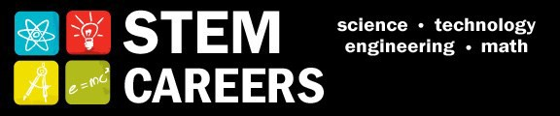
Tuesday, June 6, 2017
9:00am-8:30pm
9:00am-10:30am | STEM Careers & Noyce Scholarship  *Noyce Interns, Noyce Program Personnel, Teacher Mentors | 3408 SEC
10:30am-11:30am | What is STEM?  Mike Odell  University of Texas at Tyler
11:30am-1:00pm | Lunch | On your own
1:00pm-3:00pm | Intro to AL Course of Study & Making Research Presentations  *Noyce Interns, Noyce Program Personnel, Teacher Mentors | 3408 SEC
3:00pm-4:30pm | Molecular Gastronomy Chemistry Lecture  Marco Bonizzoni | 3408 SEC
6:30pm | Walk to Gallalee Hall | Gallalee Hall
7:00pm- 8:30pm | Astronomy Night  Gallalee Hall Observatory  Dr. Bill Keel – with J. W. Harrell  Department of Physics and Astronomy | Gallalee Hall
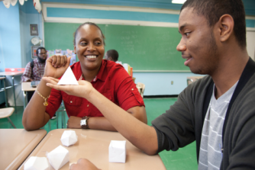

Wednesday, June 7, 2017
9:00am-5:15pm
9:00am-12:00pm | TI-Nspire Training  Jeremy Zelkowski | 3408 SEC
12:00pm-1:00pm | Lunch | On your own
1:00pm-4:30pm | TI-Nspire Training  Jeremy Zelkowski | 3408 SEC
4:30pm-5:15pm | Orientation Meeting  *Noyce Interns, Noyce Program Personnel, Teacher Mentors | Shelby Courtyard
6:30pm | Walk to Gallalee Hall | Gallalee Hall
7:00pm-9:00pm | Astronomy Night  Gallalee Hall Observatory  (Alternate Date)  Dr. Bill Keel – with J. W. Harrell  Department of Physics and Astronomy | Gallalee Hall
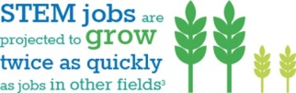

Thursday, June 8, 2017
8:00am-4:30pm
8:00am | Travel to TCTA  Krystal Flantroy | Hub Parking Lot
8:30am-11:30am | Tuscaloosa Career & Technology Academy  Engineering Lab Tour  Krystal Flantroy | TCTA
11:30am-1:00pm | Lunch | On your own
1:00pm-2:00pm | Career Orientation  Jennie King | Ferguson Center
2:00pm-4:30pm | Introduction to Coding  Jeff Gray | 3408 SEC
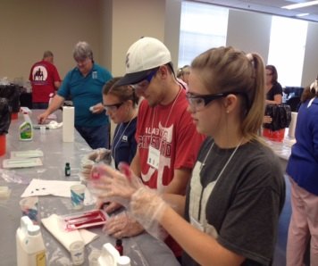

Friday, June 9, 2017
9:00am-4:30pm
9:00am-11:30pm  _________________  11:30pm-4:00pm  ________________  _________________  4:00pm – 4:30pm | Video Analysis experimental physics data collection technique  JW Harrell  ____________________________________  HS Exploration Day Preparation Activities –Review Alabama Course of Study and Next Generation Science Standards for High School Exploration Day objectives in chemistry, physics, and mathematics for activities 6/12-16*  *Library and Internet literature search and review is background for Activities 06/12-06/16 & 06/20-21. Start with the following;  - Alabama Course of Study (ACOS)  - Next Generation Science Standards (NGSS)  - Back issues of Science Teacher & Science Scope  - Search the Internet for Key Words related to objectives developed above  - Include the three dimensions of ACOS and NGSS in objectives for each lesson  - Disciplinary Core Ideas  - Scientific and Engineering Practices  - Crosscutting Concepts  _________________________________________  Reflection Paper on “What was learned” during the week 1 | 3408 SEC
