Monday, June 12, 2017- Chemistry Majors
8:00am-8:00pm
8:00am-12:00am | ASM- Materials Science Lab  Krystal Flantroy  Martin Bakker | NERC
12:00am-1:00pm | Lunch | ASM Provides
1:00pm-3:00pm | ASM- Materials Science Lab  Composite Materials  Martin Bakker | NERC
3:00pm-4:00pm | Travel To Moundville | Hub Parking Lot
4:00pm-8:00pm | Moundville Field Trip & Planning Exploration Meeting  *Noyce Interns, Noyce Program Personnel, Teacher Mentors | Conference Center

Tuesday, June 13, 2017- Chemistry Majors
8:00am-6:00pm
8:00am-12:00am | ASM- Materials Science Lab  Martin Bakker | NERC
12:00pm -1:00pm | Lunch | ASM Provides
1:00pm-5:00pm | ASM- Materials Science Lab  Martin Bakker | NERC
5:00pm-6:00pm | Using ACOS to Develop ASM Lessons  Kevin Shaughnessy  Noyce Interns, Noyce Program Personnel, Teacher Mentors | 3408 SEC

Wednesday, June 14, 2017 – Chemistry Majors
8:00am-6:00pm
8:00am-12:00am | ASM- Materials Science Lab  Martin Bakker | NERC
12:00am-1:00pm | Lunch | ASM Provides
1:00pm-5:00pm | ASM- Materials Science Lab  Martin Bakker | NERC
5:00pm-6:00pm | Research Literacy on Teaching  Noyce Interns, Teacher Mentors | Rogers Library & Internet
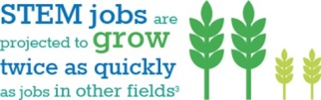

Thursday, June 15, 2017- Chemistry Majors
8:00am-6:30pm
8:00am-12:00am | ASM- Materials Science Lab  Martin Bakker | NERC
12:00am-1:00pm | Lunch | ASM Provides
1:00pm-5:00pm | ASM- Materials Science Lab  Martin Bakker | NERC
5:00pm-5:30pm  5:30pm-6:30pm | Travel to SCP  Exploration Planning Meeting  Noyce Interns, Noyce Program Personnel, Teacher Mentors | Meet at Hob Parking Lot
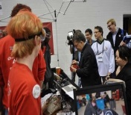
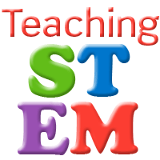

Friday, June 17, 2016- Chemistry Majors
8:00am-5:00pm
8:00am-12:00am | ASM- Materials Science Lab  Martin Bakker | NERC
12:00am-1:00pm | Lunch | ASM Provides
1:00pm-5:00pm | ASM- Materials Science Lab  Martin Bakker  Reflection Paper on “What was learned” during the week 2 | NERC

