University of Alabama

Noyce Scholars Program

Summer Internship

June 5-23, 2017

Schedule of UA Noyce Year 1 Activities

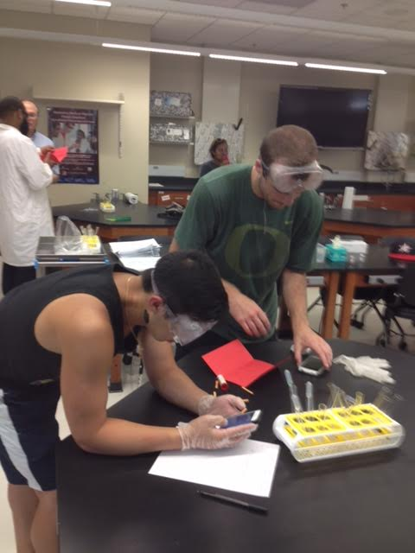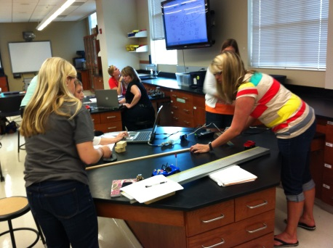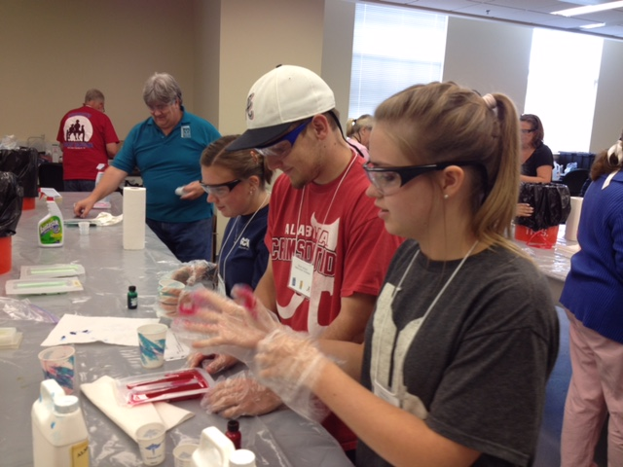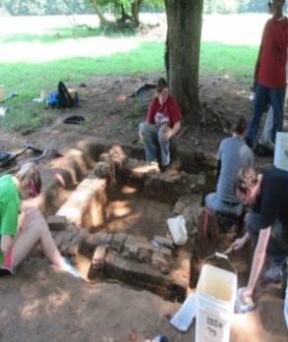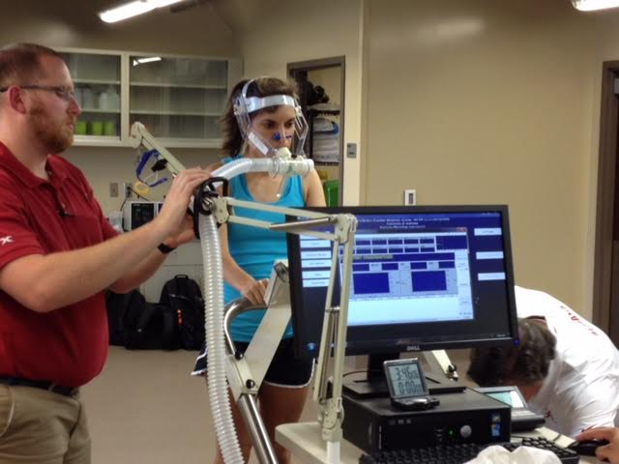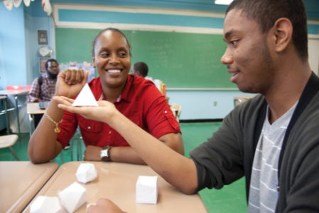
Facebook: http://www.facebook.com/UANoyce
http://education.ua.edu/academics/ci/sci/
http://www.uanoyce.ua.edu/

---------------------------------------------------------------------------------------------------------------------
This material is based on work supported by the National Science Foundation under Grant Number (DUE 1340069). Any opinions, findings, and conclusions or recommendations expressed in this material are those of the author(s) and do not necessarily reflect the views of the National Science Foundation.

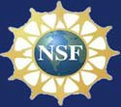

Co ntac ts for
Summer Interns h ip

Krystal Flantroy
Internship Coordinator kflantroy@crimson.ua.edu

For Further Information Contact:

Dr. Dennis Sunal Science Education dwsunal@ua.edu
UA Noyce Scholars Program and Summer Internship 2017

Be a UA Noyce Scholar

If you are a chemistry, math or physics major and have a desire to make a difference, learn more about the UA Noyce Scholars Program. UA Noyce provides 1) paid summer internships for freshmen and sophomores, 2) scholarships for juniors and seniors of up to
$16,000/year, and 3) graduate with teacher certification and a major in your field.

Dr.K.H. Shaughnessy Chemistry kshaughn@as.ua.edu

Dr. J. Zelkowski Math Education
jzelkowski@ua.edu

Dr. J. W. Harrell Physics and Astronomy jwharrelljr@gmail.com

Dr. Jim Gleason Mathematics jgleason@as.ua.edu

Description of Internship Program

The University of Alabama (UA) Robert Noyce Summer Internship and Scholar- ship/Stipend Program funded by the Na- tional Science foundation, is designed to increase the number and diversity of grad- uating teachers certified in chemistry, physics, and mathematics, and teaching in Alabama. The internship will occur over 3 weeks, June 5-23, 2017, Monday thru Fri- day each week. Intern students who re- quire housing, will live on the UA campus and attend numerous activities related to chemistry, physics and mathematics. A weekly stipend of $450 (Total = $1350) will be given to cover living costs and time committed to the internship. Year 2 returnees will receive $1800 over 4 weeks. Selection will be made by the UA Noyce Scholar Intern selection committee.
Completed applications must be
submitted by May 15, 2017 or until all positions are filled. So do apply soon.

The summer internships are open to all
U. S. citizens and permanent residents who are successful college majors in chemistry, physics or math and have a stated interest in exploring teaching in their target discipline. Examples of in- ternship experiences possible are: 1) orientation to ongoing UA research programs and labs in science, technology, engineering and math (STEM), 2) visiting and assisting in school exemplary STEM classrooms, 3) conducting an undergraduate research project, 4) participating in UA departmental STEM seminars as well as STEM education and certification seminars 5) participating in a short courses on using technology for collecting and analyzing lab data 6) exploring career potential and opportunities in STEM fields, and 7) developing model equations and printing their 3-D molecular representation.

UA Noyce 3 Week Summer Internship
Activity Highlights At-A-Glance

June 5–9, 2017
Week 1

Monday, June 5 – 10:00 am – 8:00 pm
- Check-in to Bryce Lawn dorm (4:30-6:30 Sunday or 8:30-9:30 Monday)
- Orientation *all Noyce Personnel, Teacher Mentors, and GRAs
- Overview of Noyce 2017 Summer Internship & Bama Cash Card *all Noyce Personnel, Teacher Mentors, and Interns
- Pre-testing – Career & Interest in Science/Math
- Tour of Engineering Quad Research Venues
- Afternoon Orientation Meeting at Warrior River Manderson Landing *all Noyce Personnel, Teacher Mentors, and Interns (Canceled due to weather-rescheduled)

Tuesday, June 6 – 9:00 am – 8:30 pm
- STEM Teaching and the Noyce Scholarship Program *all Noyce Personnel, Teacher Mentors, and Interns
- STEM, What is it?
- Alabama Course of Study for Science & Making Research Presentations
- Chemistry Lecture – Molecular Gastronomy

Wednesday, June 7 – 9:00 am – 8:30 pm or later
- TI-Nspire training – *Jeremy Zelkowski
- Afternoon Exploration Day Orientation Meeting *all Noyce Personnel, Teacher Mentors, and Interns
- Afternoon Orientation Meeting at Warrior River Manderson Landing Personnel, Teacher Mentors, and Interns
- Astronomy Night at the UA Observatory (Alternate Date) – Sky Observing Activities

Thursday, June 8 – 8:00 am – 4:30 pm
- Drive to Tuscaloosa Career Technology Academy (High School) Engineering Lab- with Kris Strickland
- Career Orientation with Career Center
- Introduction to Coding Apps in Science and Math

Friday, June 9– 9:00 am – 4:30 pm
- Video Analysis - experimental data collection technique
- HS Exploration Day Preparation Activities –Review Alabama Course of Study – Science and Next Generation Science Standards for high school Exploration Day objectives in chemistry, mathematics and physics for activities on 6/12-16.
- Reflection Paper on what was learned during the week

June 12-16, 2017

Week 2—Math & Physics Majors

Monday, June 12 – 8:30 am – 7:30 pm
- Using ACOS to Develop Exploration Day Lessons
- Develop Exploration Days Activities & Research Project
- Assist in TCTA Short Course-Summer of Coding
- Tour of Moundville State Park, Museum followed with Internship Planning Meeting *all Noyce Personnel, Teacher Mentors, and Interns

Tuesday, June 13 – 8:30 am – 4:30 pm
- Develop Exploration Days Activities & Research Project
- Assist in TCTA Short Course-Summer of Coding

Wednesday, June 14– 8:30 am – 5:00 pm
- Develop HS Exploration Days Activities & Research Project
- Assist in TCTA Short Course-Summer of Coding

Thursday, June 15 – 8:30 am – 6:00 pm
- Develop Exploration Days Activities & Research Project
- Assist in TCTA Short Course-Summer of Coding
- Exploration Day Planning Meeting *all Noyce Personnel, Teacher Mentors, and Interns

Friday, June 16 - 8:30 am – 4:30 pm
- Develop Exploration Days Activities & Research Project
- Guidelines for research presentations for Physics/Math students
- Math & Physics Majors—Geogebra Mini Course Activities
- Reflection Paper on what was learned during the week

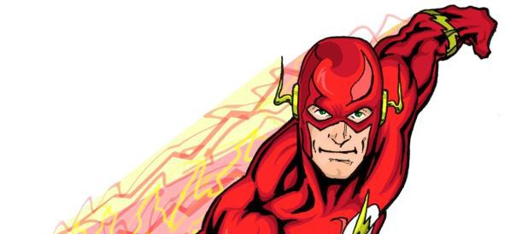
June 12 – 16, 2017

Week 2—Chemistry Majors

Monday, June 12 – 8:00 – 8:30
- ASM Materials Camp *Martin Bakker
- Tour of Moundville State Park, Museum followed with Internship Planning Meeting

Tuesday, June 13 – 8:00 – 6:30
- ASM Materials Camp *Martin Bakker
- Using ACOS and ASM to HS Develop Exploration Day Lessons

Wednesday, June 14 – 8:00 – 6:30
- ASM Materials Camp *Martin Bakker
- Develop HS Exploration Days Activities & Research Project

Thursday, June 15 – 8:00 – 6:30
- ASM Materials Camp *Martin Bakker
- Exploration Day Planning Meeting *all Noyce Personnel, Teacher Mentors, and Interns – at SCP

Friday, June 16– 8:00 – 5:00
- ASM Materials Camp *Martin Bakker - Final Session
- Reflection Paper on what was learned during the week

June 19 – 23, 2017
Week 3

Monday, June 19 – 9:00 – 4:00
- Set-Up & Preparation for Exploration Day
- 3-D Printing Lab Project

Tuesday, June 20 – 9:00 – 4:00
- HS Exploration Days Lesson and Activities – Day 1

Wednesday, June 21 – 9:00 – 5:00
- HS Exploration Days Lesson and Activities – Day 2

Thursday, June 22– 8:00 – 5:00
- HS Exploration Days Lesson and Activities Debriefing
- Work on Project Presentations-- ASM & TCTA
- 3-D Print Product pick-up - Printing of Molecules
- Career Orientation Activities—Career Center in Ferguson
- Work on Project Presentations-- ASM & TCTA

Friday, June 23– 8:00 – 4:30
- Post Tests & Focus Groups
- Check out of dorm
- STEM Teacher Panel Discussion—STEM Teaching as a Career *Noyce Interns, Noyce Program Personnel, Teacher Mentors, UA and Community College Faculty
- First Year Intern Undergraduate Research Presentations-- ASM & TCTA *Noyce Interns, Noyce Program Personnel, Teacher Mentors, UA and Community College Faculty
- Summary, Debriefing Meeting, *Noyce Program Personnel, , Teacher Mentors, UA and Community College Faculty & Noyce Interns
- Reflection Paper on what was learned during the week

UA Noyce Scholars Program

Summer Internship

June 5-23, 2017

Schedule of UA Noyce Year 1 Interns

Daily Activity Schedule

Monday, June 5, 2017
8:30am-7:00pm
8:30am-9:30am | Check In  May check into Dorm Sunday at 12:00-2:00pm  Check into Dorm Monday 8:30-9:30 am  Krystal Flantroy | Bryce Lawn Dorm
10:00am-11:00am | Orientation Noyce Internship Program  Introductions, Overview of program and weekly details of the internship activities  *Noyce Interns, Noyce Program Personnel, Teacher Mentors | 3408 SEC
11:00am-11:30am | Bama Cash  Krystal Flantroy | HUB Office
11:30am-1:00pm | Lunch | Own your Own
1:00pm  1:30pm-2:15pm | Travel to Computer Lab  Pre-Testing  Marsha Simon and Krystal Flantroy | 107 Graves Hall
2:15pm-4:00pm | Tour of Engineering Quad  Meet at Bevill Hall Lobby  Teacher Mentors | Engineering Quad
4:00pm-4:30pm | Walk to Manderson Landing
5:00pm-7:30pm | Manderson Landing Evening Meeting  *Noyce Interns, Noyce Program Personnel, Teacher Mentors | Warrior River Manderson Landing Pavilion
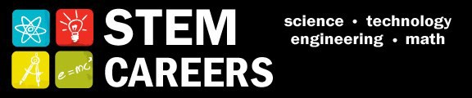
Tuesday, June 6, 2017
9:00am-8:30pm
9:00am-10:30am | STEM Careers & Noyce Scholarship  *Noyce Interns, Noyce Program Personnel, Teacher Mentors | 3408 SEC
10:30am-11:30am | What is STEM?  Mike Odell  University of Texas at Tyler
11:30am-1:00pm | Lunch | On your own
1:00pm-3:00pm | Intro to AL Course of Study & Making Research Presentations  *Noyce Interns, Noyce Program Personnel, Teacher Mentors | 3408 SEC
3:00pm-4:30pm | Molecular Gastronomy Chemistry Lecture  Marco Bonizzoni | 3408 SEC
6:30pm | Walk to Gallalee Hall | Gallalee Hall
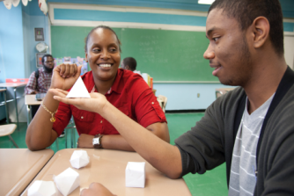

Wednesday, June 7, 2017
9:00am-5:15pm
9:00am-12:00pm | TI-Nspire Training  Jeremy Zelkowski | 3408 SEC
12:00pm-1:00pm | Lunch | On your own
1:00pm-4:30pm | TI-Nspire Training  Jeremy Zelkowski | 3408 SEC
4:30pm-5:15pm | Orientation Meeting  *Noyce Interns, Noyce Program Personnel, Teacher Mentors | Shelby Courtyard
6:30pm | Walk to Gallalee Hall | Gallalee Hall
7:00pm-9:00pm | Astronomy Night  Gallalee Hall Observatory  Ron Buta – with J. W. Harrell  Department of Physics and Astronomy | Gallalee Hall
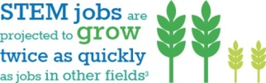

Thursday, June 8, 2017
8:00am-4:30pm
8:00am | Travel to TCTA  Krystal Flantroy | Hub Parking Lot?
8:30am-11:30am | Tuscaloosa Career & Technology Academy  Engineering Lab Tour  Krystal Flantroy | TCTA
11:30am-1:00pm | Lunch | On your own
1:00pm-2:00pm | Career Orientation  Jennie King | Ferguson Center
2:00pm-4:30pm | Introduction to Coding  Jeff Gray | 3408 SEC
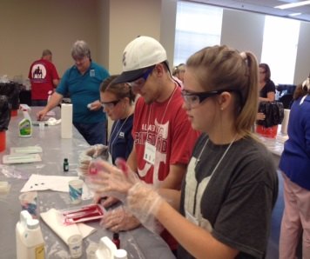

Friday, June 9, 2017
9:00am-4:30pm
9:00am-11:30pm  _________________  11:30pm-4:00pm  ________________  _________________  4:00pm – 4:30pm | Video Analysis experimental physics data collection technique  JW Harrell  ____________________________________  HS Exploration Day Preparation Activities –Review Alabama Course of Study and Next Generation Science Standards for High School Exploration Day objectives in chemistry, physics, and mathematics for activities 6/12-16*  *Library and Internet literature search and review is background for Activities 06/12-06/16 & 06/20-21. Start with the following;  - Alabama Course of Study (ACOS)  - Next Generation Science Standards (NGSS)  - Back issues of Science Teacher & Science Scope  - Search the Internet for Key Words related to objectives developed above  - Include the three dimensions of ACOS and NGSS in objectives for each lesson  - Disciplinary Core Ideas  - Scientific and Engineering Practices  - Crosscutting Concepts  _________________________________________  Reflection Paper on “What was learned” during the week 1 | 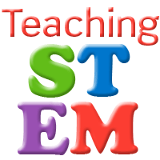  3408 SEC

Monday, June 12, 2017 – Physics and Math Majors
8:00am-8:00pm
8:00am-9:00am | Using ACOS to Develop Lessons  Dennis Sunal  Krystal Flantroy  Jeremy Zelkowski  Noyce Interns, Teacher Mentors | 3408 SEC
9:00am-11:00am | Develop HS Exploration Day Activities & Research Project  Noyce Interns, Teacher Mentors | 3408 SEC
11:00am-12:00pm | Lunch | On your own
12:00pm-12:30pm  12:30pm-3:00pm | Travel to TCTA  Assist in TCTA Classes  – Summer of Coding  Noyce Interns, Teacher Mentors | TCTA
3:00pm-4:00pm | Travel To Moundville | In Van from TCTA
4:00pm-8:00pm | Moundville Field Trip and Planning Exploration Day Meeting  All Noyce Personnel, Noyce Interns, Teacher Mentors | Conference Center
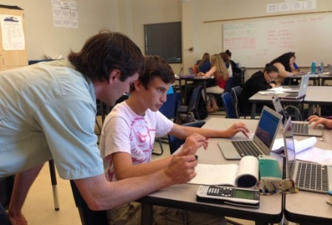

Monday, June 12, 2017- Chemistry Majors
8:00am-8:00pm
8:00am-12:00am | ASM- Materials Science Lab  Krystal Flantroy  Martin Bakker | NERC
12:00am-1:00pm | Lunch | ASM Provides
1:00pm-3:00pm | ASM- Materials Science Lab  Composite Materials  Martin Bakker | NERC
3:00pm-4:00pm | Travel To Moundville | Hub Parking Lot
4:00pm-8:00pm | Moundville Field Trip & Planning Exploration Meeting  *Noyce Interns, Noyce Program Personnel, Teacher Mentors | Conference Center

Tuesday, June 13, 2017 – Physics and Math Majors
8:00am-5:30pm
8:00am-11:30am | Develop HS Exploration Day Activities & Research Project  Noyce Interns, Teacher Mentors | 3408 SEC
11:00am-12:00pm | Lunch | On your own
12:00pm-12:30pm  12:30pm-5:30pm | Travel to TCTA  Assist TCTA Classes  -Summer of Coding | Hub Parking Lot  TCTA

Tuesday, June 13, 2017- Chemistry Majors
8:00am-6:00pm
8:00am-12:00am | ASM- Materials Science Lab  Martin Bakker | NERC
12:00pm -1:00pm | Lunch | ASM Provides
1:00pm-5:00pm | ASM- Materials Science Lab  Martin Bakker | NERC
5:00pm-6:00pm | Using ACOS to Develop ASM Lessons  Kevin Shaughnessy  Noyce Interns, Noyce Program Personnel, Teacher Mentors | 3408 SEC

Wednesday, June 14, 2017 – Physics and Math Majors
8:00am-5:30pm
8:00am-9:00am | Using ACOS to Develop Lessons  Noyce Interns, Noyce Program Personnel, Teacher Mentors | 3408 SEC
9:00am-11:00am | Lesson Literature Review  Noyce Interns, Noyce Program Personnel, Teacher Mentors | Rodgers Library
11:00pm-12:00pm | Lunch | On Your Own
12:00pm-12:30pm  12:30pm-5:30pm | Travel to TCTA  Assist in TCTA Course-  Summer of Coding  Noyce Interns, Teacher Mentors | TCTA

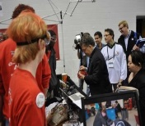

Wednesday, June 14, 2017 – Chemistry Majors
8:00am-6:00pm
8:00am-12:00am | ASM- Materials Science Lab  Martin Bakker | NERC
12:00am-1:00pm | Lunch | ASM Provides
1:00pm-5:00pm | ASM- Materials Science Lab  Martin Bakker | NERC
5:00pm-6:00pm | Research Literacy on Teaching  Noyce Interns, Teacher Mentors | Rogers Library & Internet

Thursday, June 15, 2017 – Physics and Math Majors
8:00am-6:30pm
8:00am-11:30am | Develop HS Exploration Day Activities & Research Project  Noyce Interns, Noyce Program Personnel, Teacher Mentors | 3408 SEC
11:30-12:30pm | Lunch | On Your Own
12:30pm-1:00pm | Travel to TCTA | Hub Parking Lot
1:00pm-5pm | Assist in TCTA Classes-  Summer of Coding  Noyce Interns, Noyce Program Personnel, Teacher Mentors | TCTA
5:00pm-5:30pm  5:30pm-6:30pm | Travel to SCP  Exploration Planning Meeting  Noyce Interns, Noyce Program Personnel, Teacher Mentors | In Van - Travel

Thursday, June 15, 2017- Chemistry Majors
8:00am-6:30pm
8:00am-12:00am | ASM- Materials Science Lab  Martin Bakker | NERC
12:00am-1:00pm | Lunch | ASM Provides
1:00pm-5:00pm | ASM- Materials Science Lab  Martin Bakker | NERC
5:00pm-5:30pm  5:30pm-6:30pm | Travel to SCP  Exploration Planning Meeting  Noyce Interns, Noyce Program Personnel, Teacher Mentors | Meet at Hob Parking Lot

Friday, June 16, 2017 – Physics and Math Majors
9:00am-5:00pm
9:00am-11:30am | Develop Camp Activities and Research Project  Noyce Personnel and Interns | 3408 SEC
11:30am-1:00pm | Lunch | On your own
1:00pm-5:00pm | Geogebra  Jim Gleason  Reflection Paper on “What was learned” during the week 2 | 3408 SEC

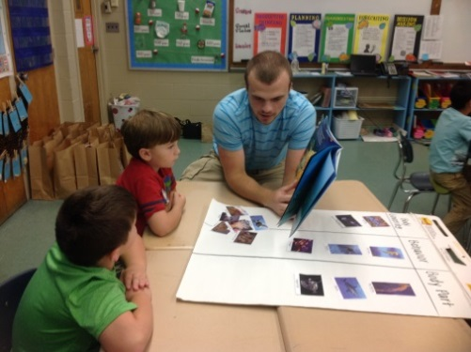

Friday, June 17, 2016- Chemistry Majors
8:00am-5:00pm
8:00am-12:00am | ASM- Materials Science Lab  Martin Bakker | NERC
12:00am-1:00pm | Lunch | ASM Provides
1:00pm-5:00pm | ASM- Materials Science Lab  Martin Bakker  Reflection Paper on “What was learned” during the week 2 | NERC

Monday, June 19, 2017
9:00am-4:30pm

9:00am-11:30am | Set-Up & Preparation  for Exploration Days  Noyce Interns, Noyce Program Personnel, Teacher Mentors | 3408 SEC
11:30am-1:00pm | Lunch | On Your Own
1:00pm-2:00pm | Finish Prep for Exploration Day  Noyce Interns, Noyce Program Personnel, Teacher Mentors | 3408 SEC
2:00pm-2:30pm  2:30pm-4:30pm | Walk to Rogers Library  Teacher Mentors  3-D Printing Lab  Vincent Scalfani | Rogers Science and Engineering Library

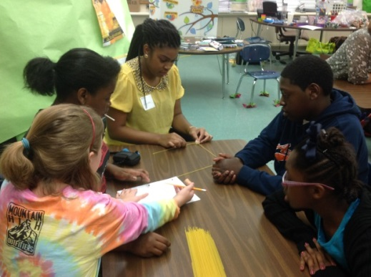

Tuesday, June 20, 2017
8:30am-4:30pm
8:30am  9:00am-12:00pm | Preparations  High School Student Exploration Day 1  Noyce Interns, Noyce Program Personnel, Teacher Mentors | 3408 SEC
12:00pm-1:00pm | Lunch
1:00pm-4:00pm  4:00pm–4:30 pm | High School Student Exploration Day 1  Noyce Interns, Noyce Program Personnel, Teacher Mentors  Clean-up & Set-up for Tuesday Day 2  Noyce Interns, Teacher Mentors | 3408 SEC

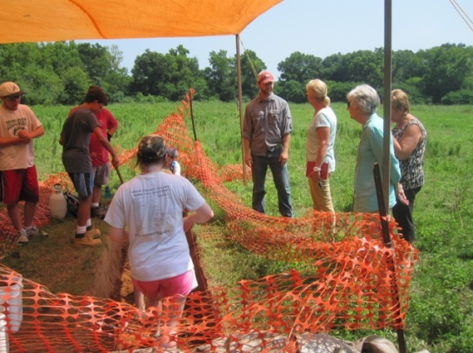

Wednesday, June 21, 201
8:30am-4:30pm

8:30 am  9:00am-12:00pm | Preparations  High School Student Exploration Day 2  Noyce Interns, Noyce Program Personnel, Teacher Mentors | 3408 SEC
12:00am-1:00pm | Lunch
1:00pm-4:00pm  4:00pm–4:30 pm | High School Student Exploration Day 2  Noyce Interns, Noyce Program Personnel, Teacher Mentors  Clean-up  Noyce Interns, Teacher Mentors | 3408 SEC

Thursday, June 22, 2017
9:00am-5:30pm

9:00am-10:00am | High School Student Camp Exploration Debrief  Noyce Interns, Noyce Program Personnel, Teacher Mentors | 3408 SEC
10:00am-12:00pm | Work on Research Project Presentations – ASM & TCTA  Noyce Interns, Teacher Mentors | 3408 SEC
12:00pm-1:00pm | Lunch | On your own
1:00pm-1:30pm | 3D Pick Up | Rogers Library
1:30pm-3:30pm  3:00pm-5:30pm | Career Orientation Follow-Up  Jennie King  Work on Research Project Presentations  Noyce Interns, Teacher Mentors | Ferguson Center  3408 SEC

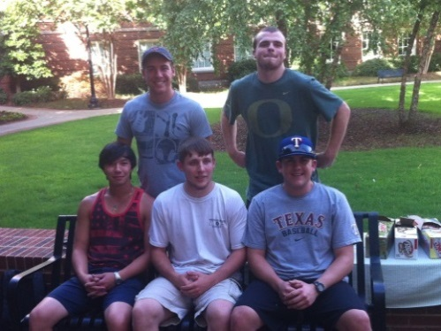

Friday, June 23, 2017
8:00am-4:00pm
8:00am-9:15am | Post Test  Focus Groups  Marsha Simon  Krysta Flantroy  Aaron Kuntz | 107 Graves Hall
9:15am-11:00am | Check out of Dorm
11:00am-12:00pm  12:00pm-3:00pm | STEM Teacher Panel  Noyce Interns, Noyce Program Personnel, Teacher Mentors  Year 1 Student Research Results Presentations  Noyce Interns, Noyce Program Personnel, Teacher Mentors | 3408 SEC  3408 SEC
3:00pm-4:00pm | Summary/Debriefing/Reflection  with 2016 Noyce Interns, Teacher Mentors, Noyce/APEX Scholarship students, Community College and Noyce Faculty/Staff  Reflection Paper on “What was learned” during the week 3 | 3408 SEC

UA-NOYCE SCHOLARS PROGRAM
PERSONNEL DIRECTORY

NSF PROJECT: DUE 1340069 The University of Alabama Noyce Scholars Program for Pre-service Teachers in Chemistry, Physics, and Mathematics
Noyce Program Personnel

Dennis W. Sunal
PI, NSF UA-Noyce Scholars Program Project
Department of Curriculum and Instruction
205C Graves Hall
College of Education
University of Alabama, Box 870232
Tuscaloosa AL 35487-0232
Ph: Office 205-348-7010 Fax: 205-348-9863 Email: dwsunal@ua.edu

JW Harrell
CO-PI, NSF UA-Noyce Scholars Program Project
CO-PI UA-APEX Project
Physics and Astronomy Department
Gallalee Hall
College of Arts and Sciences
University of Alabama, Box 870324
Tuscaloosa AL 35487
Ph: 205-792-6419 Fax: 205-348- 5051 Email: jwharrelljr@gmail.com

Jim Gleason
NSF UA-Noyce Scholars Program Project - Mathematics Laision
Department of Mathematics
College of Arts and Sciences
328C Gordon Palmer Hall
University of Alabama, Box 870350
Tuscaloosa AL 35487
Ph: Office: 205-348-5293 Email: jgleason@ua.edu

Kevin Shaughnessey
CO-PI, NSF UA-Noyce Scholars Program Project
Chair, Chemistry Department
College of Arts and Sciences
232 Shelby Hall
University of Alabama, Box 870336
Tuscaloosa AL 35487
Ph: Office 205-348-4435 Email: kshaughn@ua.edu

Cynthia S. Sunal
CO-PI, NSF UA-Noyce Scholars Program Project
Chair, Department of Curriculum and Instruction
Director, Office of Research on Teaching in the Disciplines
201 Graves Hall
Department of Curriculum and Instruction
College of Education
University of Alabama, Box 870232-0232
Tuscaloosa AL 35487
Ph: Office 205-348-0360 Fax: 205-348-9863 Email: cvsunal@ua.edu

Sharon Vincent
CO-PI, NSF UA-Noyce Scholars Program Project
UA-Noyce Community College Liaison
Box 180
Shelton State Community College
9500 Old Greensboro Rd.
Tuscaloosa, AL 35405
Ph: Office 205-391-2208 Email svincent@sheltonstate.edu

Jeremy Zelkowski
CO-PI, NSF UA-Noyce Scholars Program Project
Mathematics Education
Department of Curriculum and Instruction
212B Graves Hall
College of Education
University of Alabama, Box 870232-0232
Tuscaloosa AL 35487
Ph: Office 205-348-9499 Email: jzelkowski@ua.edu

Teacher Mentors
Mandy Anderson
NSF UA-Noyce Scholars Program Project

Danielle Djikanovic
NSF UA-Noyce Scholars Program Project

Bethany West
NSF UA-Noyce Scholars Program Project

Noyce Program Coordinator

Krystal Flantroy
NSF UA-Noyce Scholars Program Graduate Research Assistant – Administrative
Department of Curriculum and Instruction
College of Education
205B Graves Hall
University of Alabama, Box 870232-0232
Tuscaloosa AL 35487
Ph: Cell 678-984-9111 Fax: 205-348-9863 Email: kflantroy@crimson.ua.edu

Krystal Flantroy
NSF UA-Noyce Scholars Program Graduate Research Assistant – Teacher Mentor Coordinator
Department of Curriculum and Instruction
College of Education
205B Graves Hall
University of Alabama, Box 870232-0232
Tuscaloosa AL 35487
Ph: Cell 678-984-9111 Fax: 205-348-9863 Email: kflantroy@crimson.ua.edu
UA-Noyce Community College Liaisons

Bevill State Community College, Jasper
David Wages II
UA-Noyce Community College Liaison
Mathematics Department
Room 144
Bevill State Community College
2631 Temple Avenue N
Fayette, AL 35555
Ph: (205) 932-3221 ext 5193 Or 800-648-3271 ext 5193 Email: dwages@bscc.edu
Home mail address: 511 Columbus St W; Fayette, AL 35555

Calhoun Community College
Amanda J. Hendrix
UA-Noyce Community College Liaison
Natural Sciences - Chemistry
Calhoun Community College
6250 Highway 31 N
Tanner, Al 35671
Office 370H
Office #: 256-306-2832
Ph: 256-306-2832 Email: ajh@calhoun.edu
Home mail address: 1802 Eastwood Dr.
Decatur, AL 35601

Central Alabama Community College
Jeremy Carr
UA-Noyce Community College Liaison
Chemistry Instructor
Central Alabama Community College
Alexander City, Alabama
Email: jcarr@cacc.edu

Enterprise State Community College
Robert Chambless
UA-Noyce Community College Liaison
Physical Science Instructor
600 Plaza Drive, P.O. Box 1300
Enterprise, AL 36331
Ph: 334-347-2623 ext. 2258 Email: Rchambless@escc.edu

Gadsden State Community College
Brian Geislinger
UA-Noyce Community College Liaison
Physics and Astronomy Instructor
Gadsden State Community College
P.O. Box 227
Gadsden AL 35903
Office: Browder Hall Rm 206A
Ph: 256.549.8434 Fax: 256.549.8499 Email: bgeislinger@gadsdenstate.edu

Jefferson State Community College
Ali Yazdi
UA-Noyce Community College Liaison
Associate Dean of Transfer/General Studies (Jefferson Campus)
Physics Department
Jefferson State Community College
Carson Hall 317
2601 Carson Rd.
Birmingham, AL 35215
Ph: (205)856-7799 Fax: (205)856-7798 Email: ayazdi@jeffstateonline.com

Lawson State Community College
Dr. Shawanda Thomas
Mathematics Department
Lawson State Community College
1100 Ninth Avenue SW
Bessemer, AL 35022
Office A-255B (Bessemer) and B-125a (Birmingham)
PH: (205) 929-3443 Email: sthomas@lawsonstate.edu

Northwest-Shoals Community College
Kim Sheppard (Ricketts)
UA-Noyce Community College Liaison
Mathematics Instructor
Northwest-Shoals Community College
PO Box 2545
Muscle Shoals AL 35662
Ph: (256) 331-5331 Cell: (256) 702-0244 Email: kim.sheppard@nwscc.edu

Shelton State Community College
Sharon Vincent
UA-Noyce Community College Liaison
Department of Natural Sciences
Box 180
Shelton State Community College
9500 Old Greensboro Rd.
Tuscaloosa, AL 35405
Ph: Office 205-391-2208 Email svincent@sheltonstate.edu

Southern Union State Community College
Ron Sanders
Physics Instructor
Southern Union State Community College- HAC Building
1701 LaFayette Parkway
Opelika, AL 36801
Ph: 334-745-6437 ext 5456. Email: rsanders@suscc.edu

Southern Union State Community College
Tom Wynn
Chemistry Instructor
Southern Union State Community College- HAC Building
1701 LaFayette Parkway
Opelika, AL 36801
Ph: 334-745-6437 Email: twynn@suscc.edu

Wallace Community College, Selma
Tammie Briggs
UA-Noyce Community College Liaison
Arts and Sciences Department
3000 Earl Goodwin Parkway
Wallace Community College
Selma, AL 36702
Mail address: 53 Pine Mountain Ct.
Millbrook, AL 36054
Ph: 334-876-9236 Email: tammie.briggs@wccs.edu

Wallace State Community College, Hanceville
Rosalyn Meadows
UA-Noyce Community College Liaison
Chemistry Department
Wallace State Community College, Hanceville
801 Main Street
Hanceville, AL 35077
Ph: 256-352-8212 Email: rosalyn.meadows@wallacestate.edu

