The University of
Alabama

Noyce Scholarship Program

for Chemistry, Physics,
and Mathematics

Pre-Service Secondary Teachers (UA-Noyce)

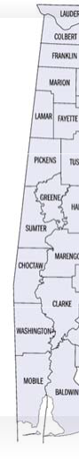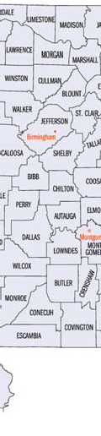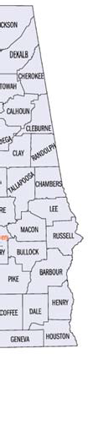

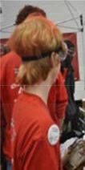
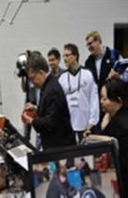
Scholarship Application

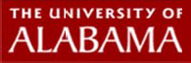

UA - Noyce Scholars Program Description
The demand for high school chemistry, physics, and mathematics teachers in the USA exceeds all other disciplines particularly in the southeast, with critical demand in Alabama.
Although 33% of U.S. high school students take one year of physics, only 19% do so in Alabama. Chemistry and physics classes have been dropped by an increasing number of Alabama schools in recent years. Alabama’s need for secondary mathematics teachers is high. During 2010, 69 secondary math teaching positions (17%) remained unfilled.
The University of Alabama Robert Noyce Scholarship/Stipend Program funded by the National Science Foundation, is designed increase the number and diversity of teachers graduating in chemistry, physics, and mathematics, and teaching in Alabama. The program is supported by The University of Alabama, Bevill State Community College, Calhoun State Community College, Gadsden State Community College, Jefferson State Community College, Lawson State Community College, Shelton State Community College, Wallace Community College - Selma, and Wallace State Community College - Hanceville. The program has 3 major goals that include 1) recruitment through early teaching experiences, 2) collaborative strategies supporting and sustaining juniors and seniors, and 3) extensive and evolving induction for graduates of the program aimed at retaining quality teachers in chemistry, physics, and mathematics in high needs Alabama school districts
UA-Noyce is designed to raise the quality of STEM teaching for all students. The program enables pre-service teachers to acquire a deeper knowledge of chemistry, physics, and mathematics content and employ more effective pedagogical strategies based on research based practice, helping grades 6-12 students to achieve higher gains. The UA- Noyce Scholars program subscribes to our nation’s philosophy that every student is entitled to the high quality educational experience, regardless of where they attend school, and assumes teachers are highly q u a l i f i e d . UA-Noyce program content in our schools fill critical needs, as t h e s e target disciplines a r e fundamental upon which a l l S T E M professions are built.
UA-Noyce is comprised of three interrelated program components covering the full student higher education experience (see figure 2). These components are designed to enhance and deepen knowledge already gained in a strong coursework program. For example, the UA undergraduate education program consists of a major in the target discipline and a major in secondary education while gaining certification in general science or mathematics. The first component, early experiences, begins with summer internship experiences for UA and Community College students at both the freshman and sophomore levels in their target disciplines at UA. The second component includes numerous junior and senior year experiences in clinical and intern experiences in school science classrooms and AMSTI/ASIM training

institutes in addition to scholarships each year. The third component involves early career development and mentoring following graduation. An induction/mentoring program will offer new teachers continued assistance and tuition in their first years of teaching through engagement with mentor teachers and faculty in online and face-to-face venues in two graduate courses that can be applied to higher level degrees and teacher certification..

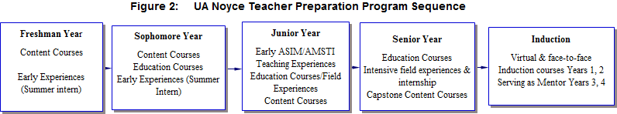

The UA-Noyce Scholarship/Stipend provides support for students seeking certification at the undergraduate, junior and senior years, or Master’s degree level to teach secondary school chemistry, physics, or mathematics. For undergraduate majors seeking certification in the target disciplines, the award consists of a maximum of $16,000 a year during the junior and senior years. For students with an undergraduate major in the target disciplines enrolled in the UA Master’s degree Alternative Certification (MA Alt Cert) program, the award consists of a maximum of $17,000 a year for up to one year of study. Care will be taken to select students from each of the target majors each year. Four or more awards are anticipated to be available each year of the program. Awards typically will be made in November and March for the following spring or fall semester.

Minimum Criteria Required for Submission of Application

- United States citizens, nationals of the United States, or aliens lawfully admitted to the United States for permanent residence,
- College/university major is in chemistry, physics, or mathematics
- Attainment of (a) for scholarships - at least junior status with a minimum of 61 hours completed in the target disciplines or (b) for stipends - acceptance into UA MA degree alternative certification education program in General Science or Mathematics (or a single field certification program) with a major in the target disciplines.
- Academic Merit:
  - Undergraduates: Minimum 2.75, preferred 3.0+, overall GPA based on full academic transcripts with at least 61 hours in the target major program for undergraduates with a 2.5+ GPA minimum in the major courses alone and acceptable ACT/SAT scores. Note: For current UA students Degree Works may be able to provide transcripts.
  - Graduates: a completed appropriate Bachelor’s degree in the targeted majors with a minimum overall GPA based on full undergraduate academic transcripts of 3.0+ with a 2.5+ GPA minimum in the major courses alone and acceptable GRE/MAT scores. Note: For current UA students Degree Works may be able to provide transcripts.

Criteria Used After Minimum Eligibility is Established (rank ordered)
- Minorities, persons with disabilities, and other underrepresented students in the three content areas
- Financial need based on current Free Application for Federal Student Aid (FAFSA) report submitted to UA Office of Student Financial Aid
- Priority is established as: [1] chemistry majors, [2] mathematics majors, and [3] physics majors
- 3 letters of recommendation from teachers, professors, and/or supervisors in STEM professions. Letters should address your academic achievements, ability to work with others, and/or your potential as a teacher.
- A personal creed statement (1000 words or less) addressing the following:
  - Why are you interested in teaching high school in the target certification area?
  - What have you done professionally and personally to prepare you to become a teacher (e.g. participation in the UA-Noyce internship experiences, tutoring, serving as a Learning Assistant, participation in administering/judging Science Olympiad or a secondary school science fair, Big Brother/Big Sister, other)
  - How will this scholarship/stipend help you reach this goal?
  - What is your commitment to working in a 'high-needs' school? Include possible intended high needs region in which you may seek employment as a STEM teacher.

Scholarship/Stipend Graduation Progress Review
The Noyce Scholar, recipient will sign a contract and a promissory note upon identification as a recipient. The scholarship/stipend will be treated as a “forgivable loan.” The contract will be considered satisfied if all teaching and follow-up requirements are completed.

The continuing eligibility of scholarship/stipend recipients during their academic program will be monitored each semester using three criteria: (1) maintaining minimum undergraduate overall GPA of 2.75 and 3.0 for graduate students, both with an additional minimum in target major only courses, (2) making adequate continuous progress towards degree completion, and (3) demonstrating appropriate professional dispositions. UA-Noyce recipients will provide a written report to the UA-Noyce scholarship/stipend committee or a designated representative each semester on a regular schedule. Recipients who do not meet these requirements will be notified and counseled. Recipients will lose their funding for the subsequent semester if the requirements are not met. In addition, if the recipient fails to comply, the promissory note for the funds already received, or portion thereof, becomes due and payable with interest.

Additional Criteria for Maintaining the Scholarship/Stipend are:
- Participation in announced day long and weekend workshops held in fall, spring, and summer semesters during each year as a part of the commitment of the scholarship/stipend.
- Participation in UA-Noyce evaluation (i.e. surveys, interviews, focus groups, teaching observations) as part of the UA-Noyce continuing assessment program.

Scholarship/Stipend Follow-up Teaching and Educational Requirements
UA-Noyce recipients are required to report yearly on professional activities following graduation to the UA-Noyce Noyce scholarship/stipend committee or a designated representative.
Annual review of compliance checks the criteria below and determines consequences of defaults. If the recipient fails to comply, the whole promissory note, or portion thereof, becomes due and payable with interest. In addition the annual review of compliance checks will be conducted to determine whether induction course tuition (2 courses) will be provided. The University of Alabama has well established policies and procedures in place to monitor, track, and encourage compliance with financial aid agreements and we intend to take advantage of this expertise as necessary.

Criteria are:
- Recipients must commit to teaching two years as a STEM teacher in a high school or middle school in a high-need school district in Alabama for each year of scholarship/stipend received. High-need school districts are defined as having: (a) a high percentage of individuals from families with incomes below the poverty line, (b) a high percentage of secondary science and/or mathematics school teachers not teaching in the content area in which the teachers were trained to teach, or (c) a high teacher turnover rate.
- Participation in UA-Noyce evaluation (i.e. surveys, interviews, focus groups, teaching observations) as part of the UA-Noyce continuing assessment program.
- Participation in the University of Alabama induction and mentoring program including completion of two induction Masters Degree level graduate courses Note: Tuition will be paid by UA-Noyce for the graduate courses if completed before 8/15/19.
- Maintain contact and provide UA-Noyce designated representative, an annual certification of employment and current contact information for the time specified in (1).

Application Information
- The Application Form below will be available at the following website and must be submitted electronically by the announced due dates of November 1 and April 1 each year.
Application should be made the semester before you wish to enter the program http://www.education.ua.edu/secondary/science

- Current UA students’ records will be obtained by UA-Noyce from Degree Works. Transfer students must provide official sealed current transcripts, sent to Dennis Sunal, P.O. Box 870232, The University of Alabama, Tuscaloosa, AL 35487-0323.

For additional information contact:
D. W. Sunal, Department of Curriculum and Instruction, Box 870232, University of Alabama or email responses to this application to dwsunal@bama.ua.edu
---------------------------------------------------------------------------------------------------------------------
This material is based upon work supported by the National Science Foundation under Grant Number (DUE 1340069). Any opinions, findings, and conclusions or recommendations expressed in this material are those of the author(s) and do not necessarily reflect the views of the National Science Foundation.

UA-Noyce Scholarship Application Form
This form is available on http://www.education.ua.edu/secondary/science

Deadlines for registration for the next semester: November 1 and April 6 each year.
Application should be made the semester before you wish to enter the program.

- Name:
- Student UA ID Number:
- Permanent Address: (Number and street, city, state, zip code)

- Local Address if different from permanent address ((Number and street, city, state, zip code)

- Email address:
- Phone: (7) Date of Birth:

- Gender: Male
Female
- Academic Major

- A) If undergraduate: Attainment of at least junior status with at least 61 hours completed (with sophomore status of chemistry, physics, or mathematics major course work completed).
  - Overall credit hours of
  - Target major course work credit hours (only) completed
or B) If Graduate: Undergraduate degree in Major obtained at which university?
- A. Overall GPA based on full transcript with at least 61 hours for undergraduates GPA in appropriate Major
B. Overall GPA based on full undergraduate academic transcripts in completed appropriate Bachelor’s degree major and GRE/MAT score (indicate which one).
- Anticipated semester/year that you will graduate with certification at UA:
- Schools attended from high school to present (School, City, State, Dates attended):
A.

B.

C.

- I am a: US Citizen Permanent Resident US National

- Race/Ethnicity/Identified Disability status (optional):
- Three individuals submitting recommendations. Note: Referees should send their letters

directly Name

to Dennis Sunal at dwsunal@bama.ua.edu
Affiliation

Relationship

- FAFSA: Indicate whether or not you have a financial need statement (FAFSA) on file at the University of Alabama.

YES
NO

- Below, complete a personal creed statement (1000 words or less) addressing the following:
- Why are you interested in teaching high school in the target certification area?

- What have y (e.g. particip
u done professionally and personally to prepare you to become a teacher tion in the UA-Noyce internship experiences, tutoring, serving as a

Learning Assistant, participation in administering/judging Science Olympiad or a secondary school science fair, Big Brother/Big Sister, other)
- How will this scholarship/stipend help you reach this goal?
- What is your commitment to working in a 'high-needs' school? Include possible intended high needs region in which you may seek employment as a STEM teacher.

Submit completed form to Dennis Sunal at dwsunal@bama.ua.edu

