Monday, June 19, 2017
9:00am-4:30pm

9:00am-11:30am | Set-Up & Preparation  for Exploration Days  Noyce Interns, Noyce Program Personnel, Teacher Mentors | 3408 SEC
11:30am-1:00pm | Lunch | On Your Own
1:00pm-2:00pm | Finish Prep for Exploration Day  Noyce Interns, Noyce Program Personnel, Teacher Mentors | 3408 SEC
2:00pm-2:30pm  2:30pm-4:30pm | Walk to Rogers Library  Teacher Mentors  3-D Printing Lab  Vincent Scalfani | Rogers Science and Engineering Library

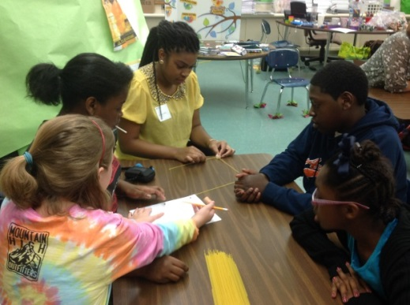

Tuesday, June 20, 2017
8:30am-4:30pm
8:30am  9:00am-12:00pm | Preparations  High School Student Exploration Day 1  Noyce Interns, Noyce Program Personnel, Teacher Mentors | 3408 SEC
12:00pm-1:00pm | Lunch
1:00pm-4:00pm  4:00pm–4:30 pm | High School Student Exploration Day 1  Noyce Interns, Noyce Program Personnel, Teacher Mentors  Clean-up & Set-up for Tuesday Day 2  Noyce Interns, Teacher Mentors | 3408 SEC

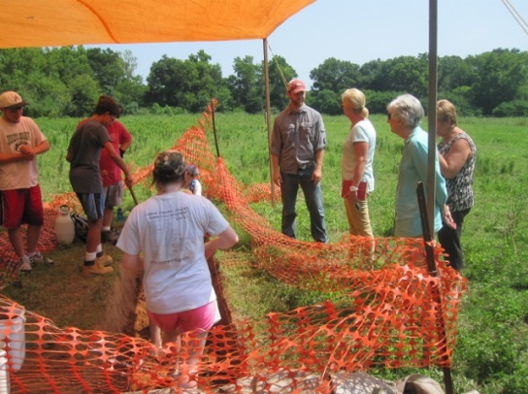

Wednesday, June 21, 201
8:30am-4:30pm

8:30 am  9:00am-12:00pm | Preparations  High School Student Exploration Day 2  Noyce Interns, Noyce Program Personnel, Teacher Mentors | 3408 SEC
12:00am-1:00pm | Lunch
1:00pm-4:00pm  4:00pm–4:30 pm | High School Student Exploration Day 2  Noyce Interns, Noyce Program Personnel, Teacher Mentors  Clean-up  Noyce Interns, Teacher Mentors | 3408 SEC
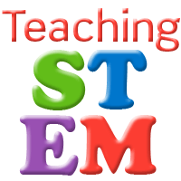

Thursday, June 22, 2017
9:00am-5:30pm

9:00am-10:00am | High School Student Camp Exploration Debrief  Noyce Interns, Noyce Program Personnel, Teacher Mentors | 3408 SEC
10:00am-12:00pm | Work on Research Project Presentations – ASM & TCTA  Noyce Interns, Teacher Mentors | 3408 SEC
12:00pm-1:00pm | Lunch | On your own
1:00pm-1:30pm | 3D Pick Up | Rogers Library
1:30pm-3:30pm  3:00pm-5:30pm | Career Orientation Follow-Up  Jennie King  Work on Research Project Presentations  Noyce Interns, Teacher Mentors | Ferguson Center  3408 SEC

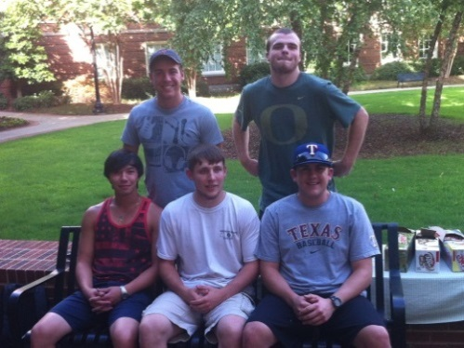

Friday, June 23, 2017
8:00am-4:00pm
8:00am-9:15am | Post Test  Focus Groups  Marsha Simon  Krysta Flantroy  Aaron Kuntz | 107 Graves Hall
9:15am-11:00am | Check out of Dorm
11:00am-12:00pm  12:00pm-3:00pm | STEM Teacher Panel  Noyce Interns, Noyce Program Personnel, Teacher Mentors  Year 1 Student Research Results Presentations  Noyce Interns, Noyce Program Personnel, Teacher Mentors | 3408 SEC  3408 SEC
3:00pm-4:00pm | Summary/Debriefing/Reflection  with 2016 Noyce Interns, Teacher Mentors, Noyce/APEX Scholarship students, Community College and Noyce Faculty/Staff  Reflection Paper on “What was learned” during the week 3 | 3408 SEC

