UA NOYCE
STEM HIGH SCHOOL
EXPLORATION DAYS
The STEM Exploration is a two-day academic enrichment program for 20 promising high school students grades 9-12 who are interested in science, the Exploration activities are designed to solve introductory problems in physics and chemistry using technology and to explore how things work. Algebra I and physical science courses would be helpful but are not required.

WHEN

Tuesday, & Wednesday June 20 - 21, 2017
9:00 am—4:00 pm

Cost: Free (including lunch) excluding transportation

WHERE

Science & Engineering Complex (SEC—Room 3408)
Directions: http://eng.ua.edu/about/directions/

Completed Applications due by June 5, 2017 or until all
positions filled.
Application for the 2017 STEM Exploration can be found online at http://uanoyce.ua.edu/ or attached to this flyer.

Email questions or completed applications to:
Dennis Sunal - dwsunal@ua.edu or
Krystal Flantroy - kflantroy@crimson.ua.edu

HIGH SCHOOL STUDENTS GRADES 9-12

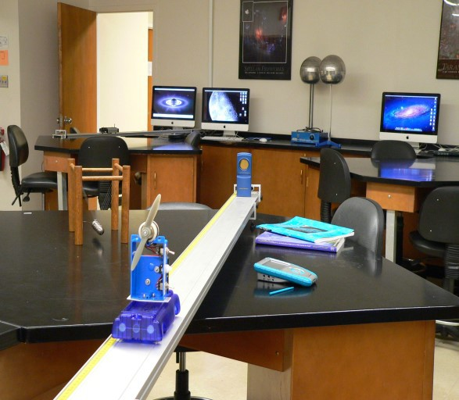

SPONSORS
UA Noyce Program
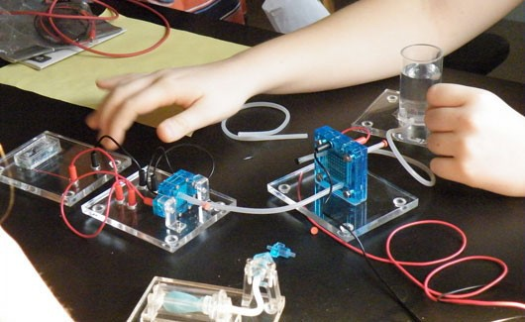
Departments of: Curriculum & Instruction Physics and Astronomy Mathematics
Chemistry

UA STEM High School Exploration Days

Tuesday & Wednesday, June 20 – 21, 2017

The STEM Exploration is a two-day academic enrichment program for 20 promising high school students grades 9-12 who are interested in science, technology, engineering and math, with a focus in the physical sciences. The days are sponsored by the University of Alabama Noyce Program and the National Science Foundation. The exploration day’s activities are designed to solve introductory problems in STEM and to explore how things work. Algebra I and physical science courses would be helpful but are not required.

The program is free of charge to participating students, includes lunch, but does not include transportation to and from the site.

Completed Applications due by June 5, 2017 or until all positions filled.
Email completed application to Krystal Flantroy at kflantroy@crimson.ua.edu.
Application to UA NOYCE High School STEM Exploration Days
Name:
Grade Completed (rising ninth graders welcome):
School:
Home Address:
Email Address:
Phone #:
High School Science and Math Courses Taken:
Career Interest:
After acceptance to the program, further information will be sent to participants detailing the UA campus building and time. For questions, please contact Krystal Flantroy at kflantroy@crimson.ua.edu.

